**Variables Description:**

**famatt1 through famatt12**: Children’s attitude towards family. The higher values depict modern attitude whereas lower values depict traditional attitude.

Recommendation: The variable should be called Attitude towards Gender Roles.

The questionnaire for the variables is respectively:

1. FAMILY ATTITUDES - A WOMAN'S PLACE IS IN THE HOME, NOT THE OFFICE OR SHOP 2020
2. FAMILY ATTITUDES - WIFE WHO CARRIES OUT FULL FAMILY RESPONSIBILITIES DOES NOT HAVE TIME FOR OUTSIDE EMPLOYMENT 2020
3. FAMILY ATTITUDES - A WORKING WIFE FEELS MORE USEFUL THAN ONE WHO DOES NOT HAVE JOB 2020
4. FAMILY ATTITUDES - EMPLOYMENT OF WIVES LEADS TO MORE JUVENILE DELINQUENCY 2020
5. FAMILY ATTITUDES - EMPLOYMENT OF BOTH PARENTS IS NECESSARY TO KEEP UP WITH HIGH COST OF LIVING 2020
6. FAMILY ATTITUDES - IT IS MUCH BETTER IF MAN IS ACHIEVER OUTSIDE HOME AND WOMAN TAKES CARE OF HOME AND FAMILY 2020
7. FAMILY ATTITUDES - MEN SHOULD SHARE HOUSEWORK WITH WOMEN 2020
8. FAMILY ATTITUDES - WOMEN ARE MUCH HAPPIER IF STAY AT HOME AND TAKE CARE OF THEIR CHILDREN 2020
9. FAMILY ATTITUDES - HAVING A JOB IS THE BEST WAY FOR A WOMAN TO BE AN INDEPENDENT PERSON 2020
10. FAMILY ATTITUDES - PEOPLE IN A COMMITTED RELATIONSHIP ARE GENERALLY HAPPIER THAN PEOPLE WHO ARE NOT 2020
11. FAMILY ATTITUDES - IT IS BETTER TO BE IN A BAD RELATIONSHIP THAN IN NO RELATIONSHIP 2020
12. FAMILY ATTITUDES - IT WOULD BE OKAY FOR A MAN AND A WOMAN TO HAVE CHILDREN WITHIN A COHABITING RELATIONSHIP 2020

Reverse coded- famatt1, famatt2, famatt4, famatt6, famatt8, famatt10, famatt11. Reverse coding is done in the following way- 1 is mapped to 4, 2 is mapped to 3, 3 is mapped to 2 and 4 is mapped to 1.

**Famattscore:** Summation of the above-mentioned variables. Higher values depict a modern attitude.

**fam1 through fam8:** Mother’s attitude towards family and gender roles. The higher values depict modern attitude whereas lower values depict traditional attitude.

Recommendation: The variable should be called Mother’s Attitude towards Gender Roles.

Questions associated with the variables fam1 through fam8 are respectively:

1. FAMILY ATTITUDES - WOMAN'S PLACE IS IN THE HOME? 2004
2. FAMILY ATTITUDES - WIFE WITH FAMILY HAS NO TIME FOR OTHER EMPLOYMENT? 2004
3. FAMILY ATTITUDES - WORKING WIFE FEELS MORE USEFUL? 2004
4. FAMILY ATTITUDES - EMPLOYMENT OF WIVES LEADS TO JUVENILE DELINQUENCY? 2004
5. FAMILY ATTITUDES - INFLATION NECESSITATES EMPLOYMENT OF BOTH PARENTS? 2004
6. FAMILY ATTITUDES - TRADITIONAL HUSBAND/WIFE ROLES BEST? 2004
7. FAMILY ATTITUDES - MEN SHOULD SHARE HOUSEWORK? 2004
8. FAMILY ATTITUDES - WOMEN ARE HAPPIER IN TRADITIONAL ROLES?

Reverse coded- fam3, fam5 and fam7.

**famattmom:** Summation of the above-mentioned variables. Higher values depict a modern attitude.

**Dataset Description:**

The dataset is a subset of the original dataset where all famatt1 through famatt12 and fam1 through fam2 are greater than 0 (non-null value).

Additional- incomewages is a subset where income in wages and job satisfaction are non-null. incomebus is a subset where at least one of income in wages or income through business is non-null.

**Descriptive Statistics:**

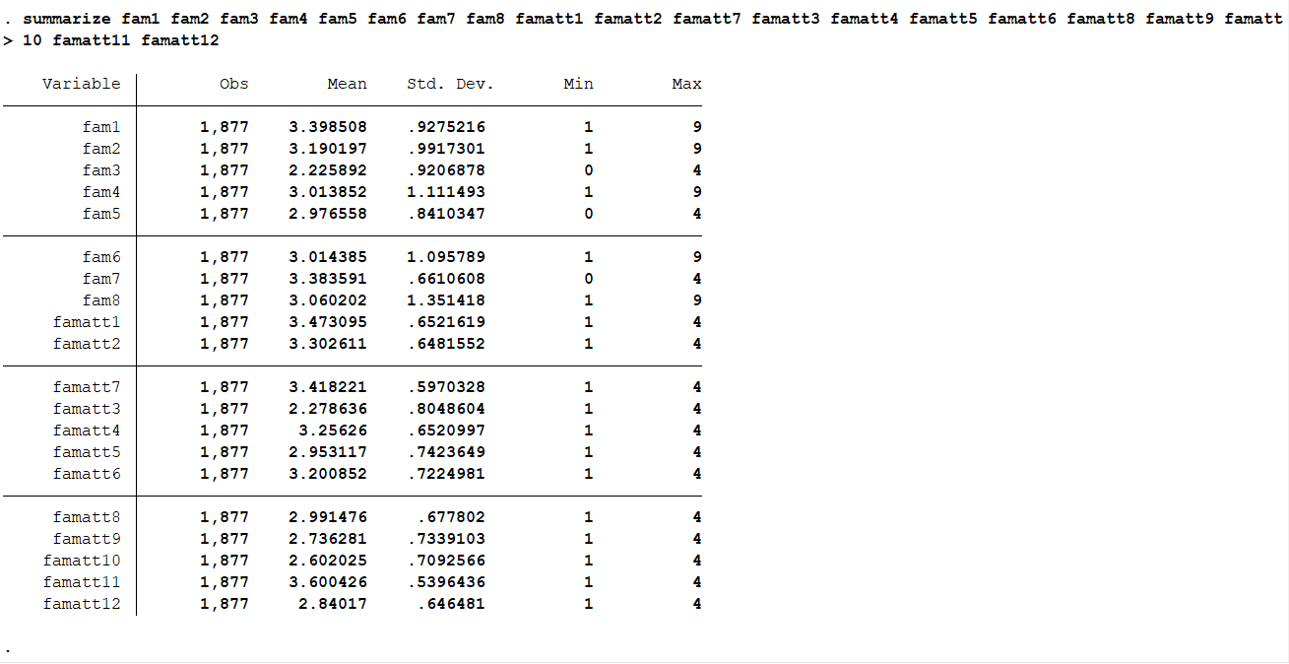

**Results:**

1. **Regression Results:**

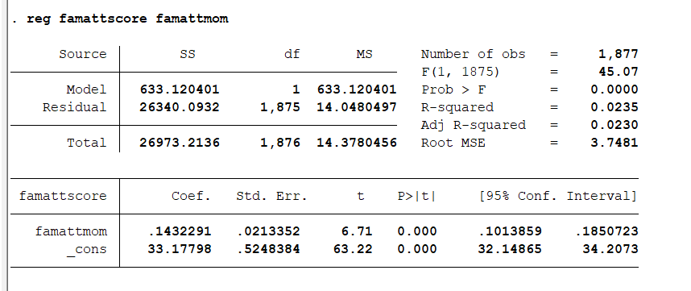

There is a significant correlation between family attitudes of a child and that of mother. But it still is not enough to imply that there’s a causation, i.e. it is passed down from a mother to her child. (Correlation does not imply causation) Further study is required to establish a causal relationship.

(You might mention the information enclosed by the red rectangle in your thesis)

1. **t-test for equality of means:** A t-test was conducted to assess if there’s a significant difference in attitude towards gender roles between the two sexes.

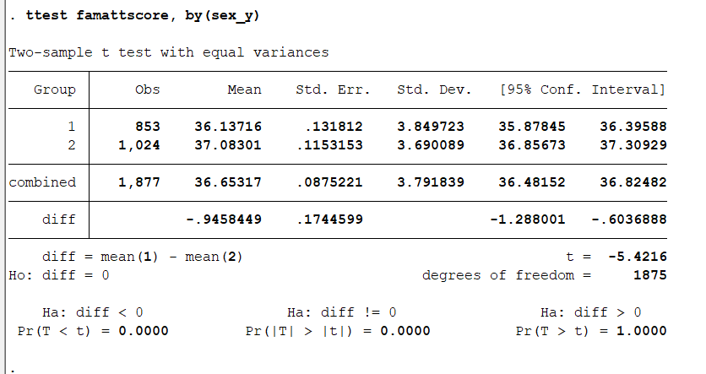

P-value less than alpha (0.05) conveys that there’s a significant difference in mean value of ‘attitude towards gender role’ between the two sexes.

Sex variable values: 1- Male, 2- Female.